This week in Wilderness Medicine we discussed Jellyfish: the types that medical professionals should know about as well as treatment and management for the various envenomations. We reviewed the article Jellyfish Stings: A Practical Approach from the journal of WILDERNESS & ENVIRONMENTAL MEDICINE by Najla A. Lakkis, Grace J. Maalouf, Dina M. Mahmassani

While most jellyfish will cause cutaneous irritation and pain, only a small subset of species will cause systemic syndrome and can lead to death and serious harm even with minor contact. These are summarized the the follow table.

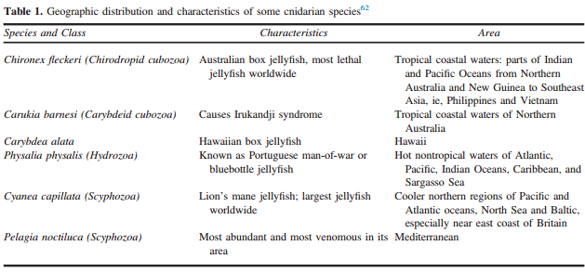

Treatment for Jellyfish stings starts with the standard A/B/Cs of emergency medicine. Once the patient is cleared of emergent life threatening issues then the sting themselves should be addressed. All stings should be washed with SALT WATER, not fresh water, to ensure that the remaining cells do not release more toxins. Remaining stingers and cells should then be removed from the body manually. Pain control and local anesthetics is key to proper management of these wounds. While an exact management of these wounds depends on the species of jellyfish, the following flow table is a useful tool for the general practitioners.
The Treatment Plan:
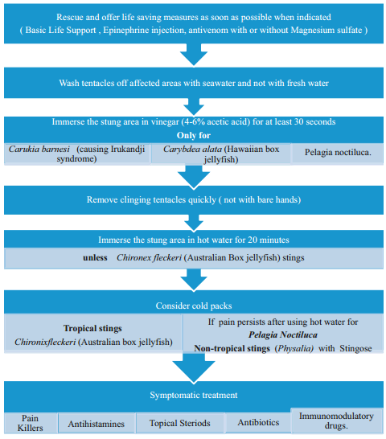

Images and tables borrowed from:
Jellyfish Stings: A Practical Approach. WILDERNESS & ENVIRONMENTAL MEDICINE by Najla A. Lakkis, MD, MPH; Grace J. Maalouf, MD; Dina M. Mahmassani, RN

